Exhaustive Analysis of Indian Agriculture Sector Using Power BI

WEEK1

PROJECT REPORT

**Importing, Pre Processing & Data Modelling**

ACTIVITY – 1

Downloading the required Softwares

🡪POWERBI

LINK :--

<https://www.microsoft.com/en-us/download/details.aspx?id=58494>

🡪EXCEL

🡪CSV

🡪MICROSOFT 365 OFFICE

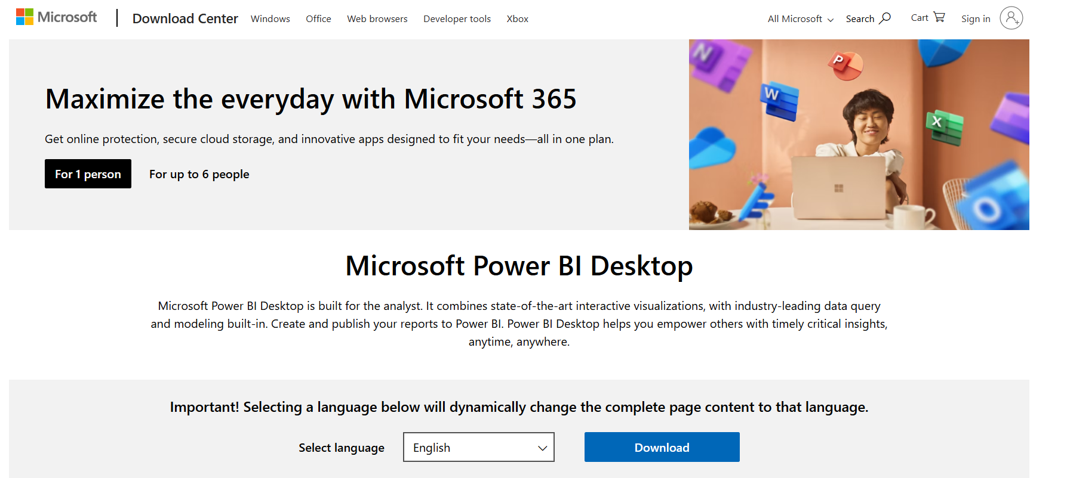

ACTIVITY 2 ::

DOWNLOAD THE DATASET 🡪

Exhaustive Analysis of Indian Agriculture.CSV

WE CAN DOWNLOAD THE DATASET FROM

SKILLS4FUTHURE(LMS) OR OPENDATA

PROVIDED BY KAGGLE , INDIAN GOV,RTI

NOW WE NEED TO IMPORT IT POWER BI

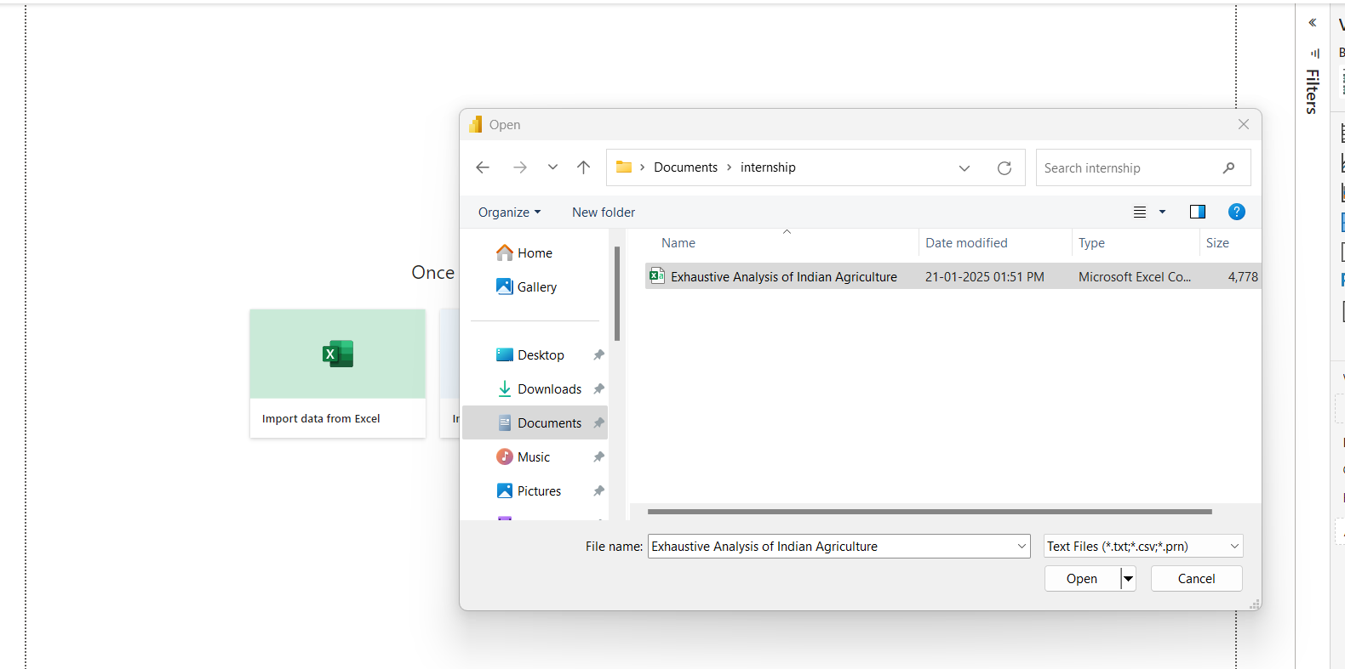

WE NEED TO SELECT THE METHOD OF IMPORTING ACCORDINLY

FILE WITH SUTIABLE FORMAT………

ACTIVITY 3 ::->

NOW WE NEED LOAD THE DATA

WE ARE USING ETL METHOD

E -> EXTRACT THE DATA/IMPORT THE DATA

T -> TRANSFORM OF DATA

L -> LOAD THE DATA

IMPORTING IS DONE IN ACTIVITY 2

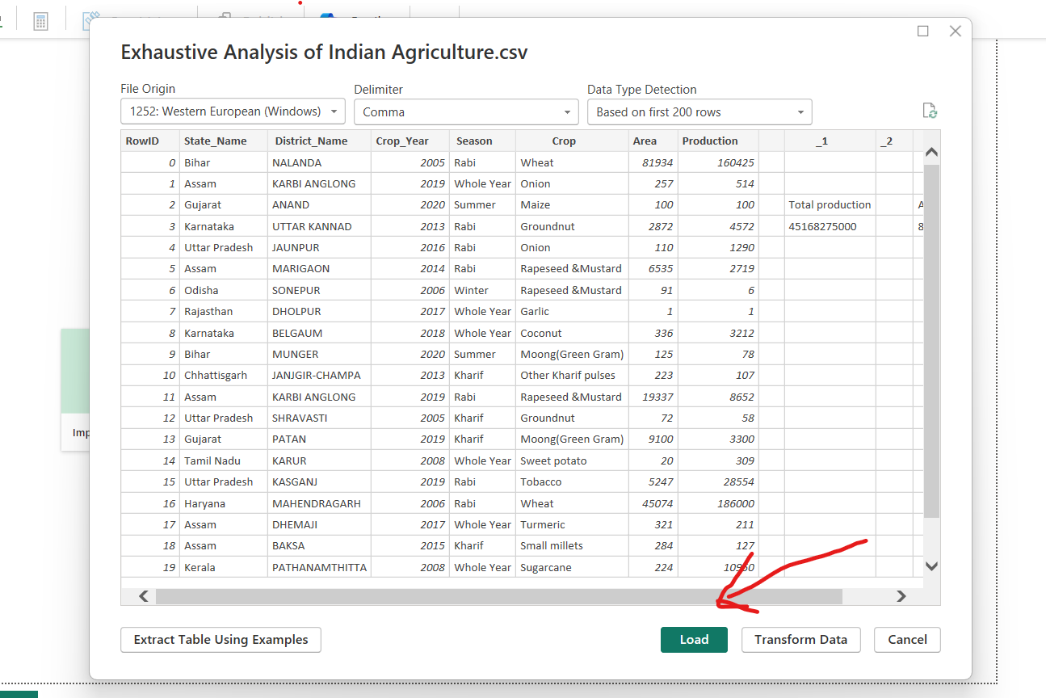

ACTIVITY 4 ->

NOW WE NEED TO TRANSFORM THE DATA

WE COVER

-🡪 REMOVING BLANK ROWS/COLUMS

🡪REMOVING NULL VALUES

* ADDING COUNTER TO CHECK THE QUALITY OF COLUMNS

STEP 1 ----

-🡪 REMOVING BLANK ROWS/COLUMS

IN TABLE VIEW

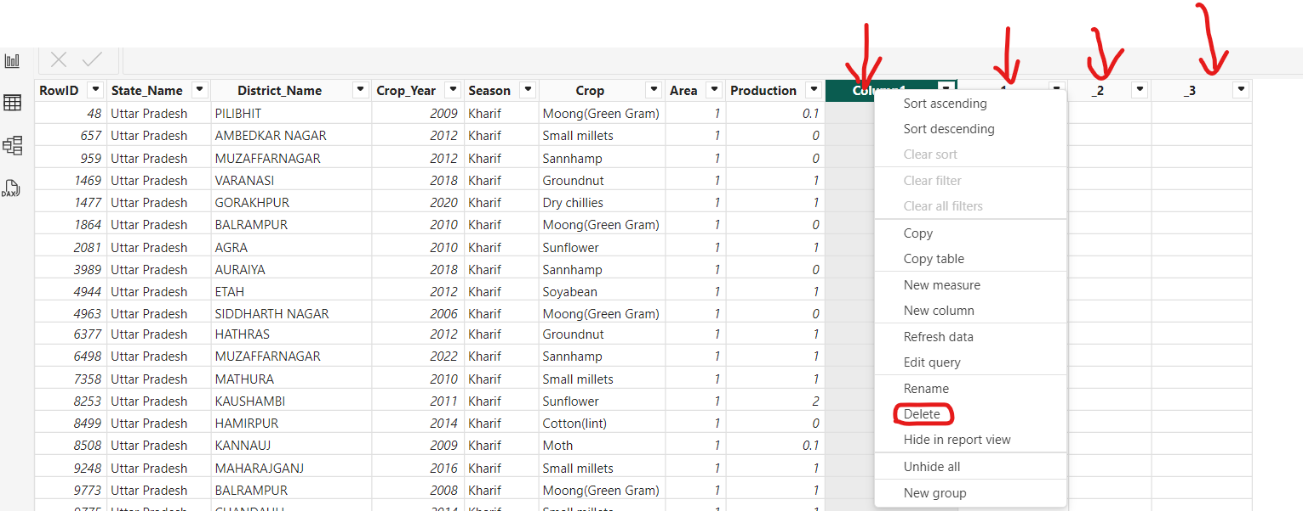

AFTER DELETING THE COLUNM 1,2,3

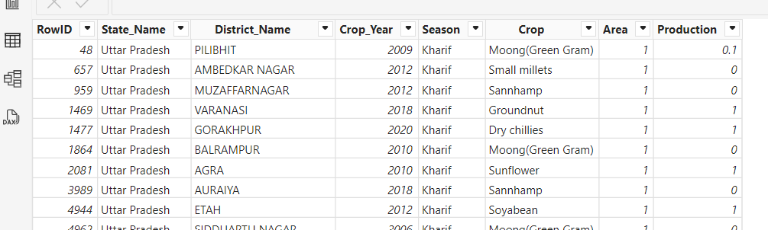

NOW WE GOING TRANFORM QUERY :

WHICH HELPS TO CLEAN DATA

REMOVE DUPLICATE VALUES

AND CLEAN BLANK LINES

POWER QUERY EDITOR 🡪

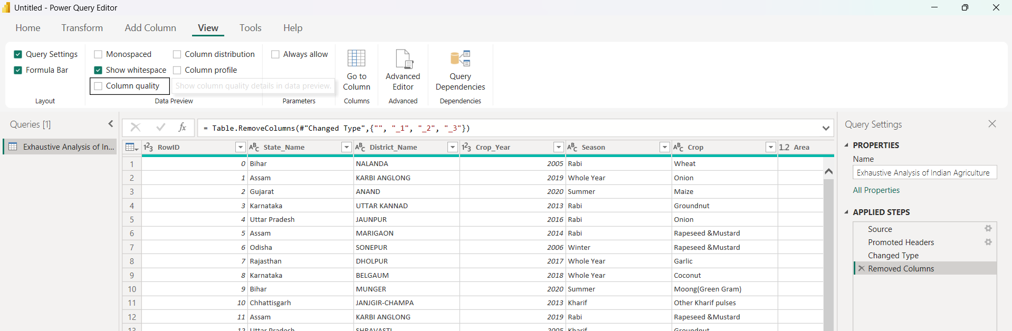

NOW WE ADD QUALITY COLUMN AND REMOVE BLANK LINES

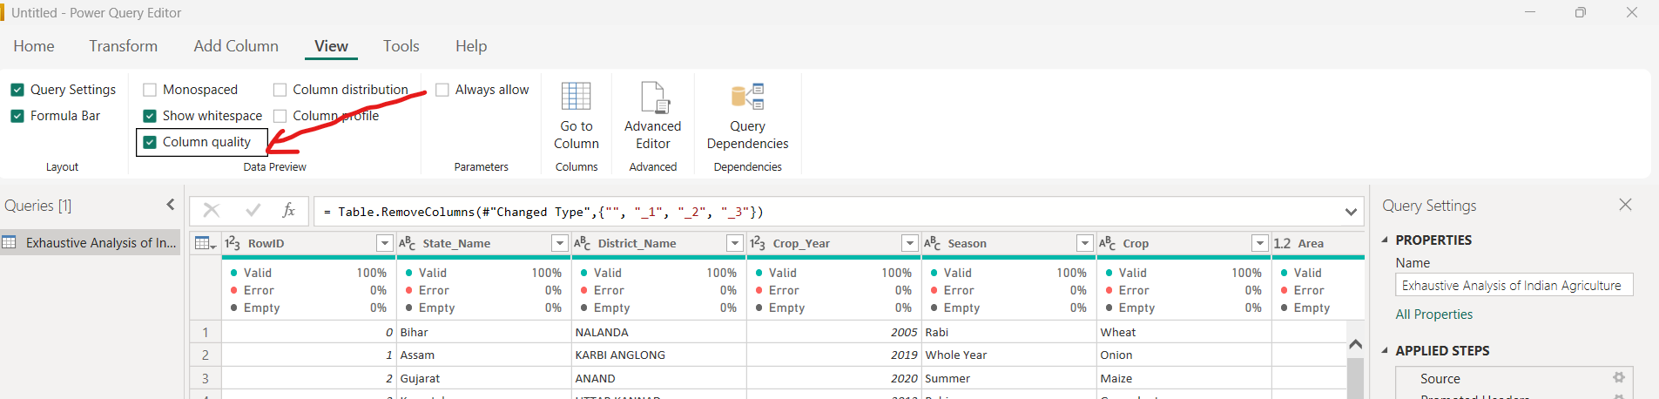

NOW WE CAN REMOVE BLANK LINES

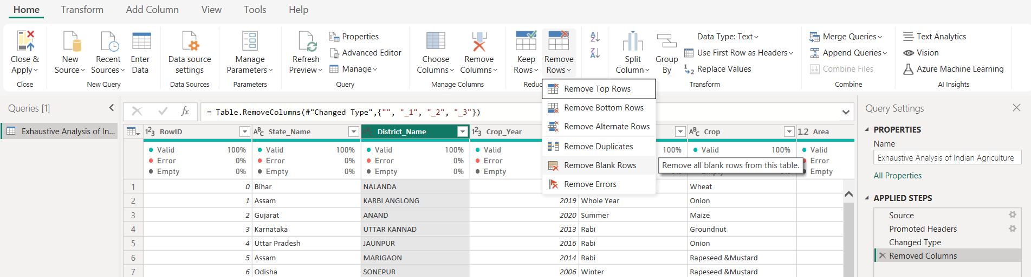

COMPLETED----------------------------------------------------------------------

REPORT ON WEEK1 PROJECT

DONE BY JONNADA NIHANTH REDDY .